The IET

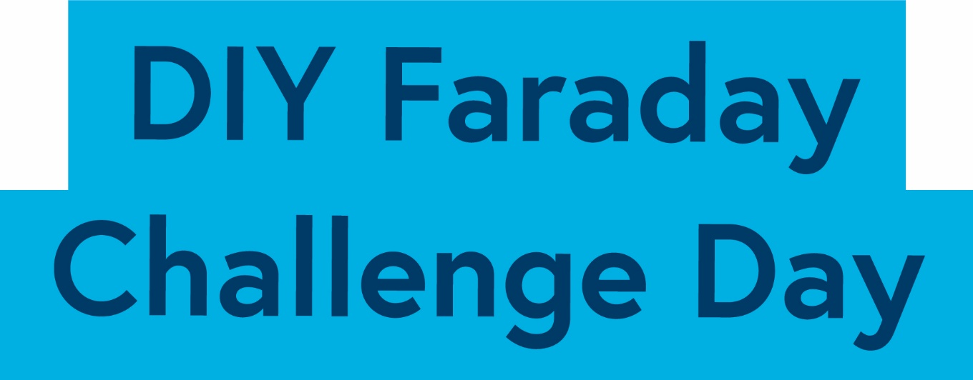

Network Rail

Student Booklet

Could you be our engineer….?

With thanks to our supporters and sponsors…

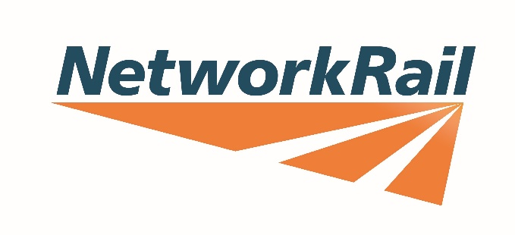
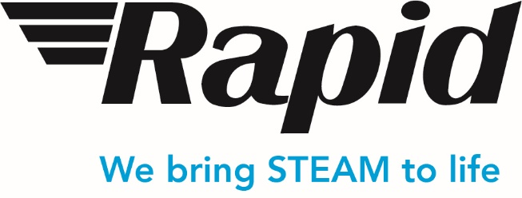

Keith Thrower OBE FREng FIET

Contents

- The Context …………………………………………………………………………….. 4
- The Brief ………………………………………………………………………………… 5
- Schedule for the day ………………………………………………………………….. 6
- Engineering apprenticeship …………………………………………………………… 7
- Shop resource sheet …………………………………………………………………… 8
- Assessment information and criteria …………………………………………………. 12

Context

Our railways help us to get to work, to go on days out, to travel to our favourite sports and meet up with friends and family. They also help transport things we use in our daily lives, our food, our post, even our vehicles. Without them our lives would be very different.
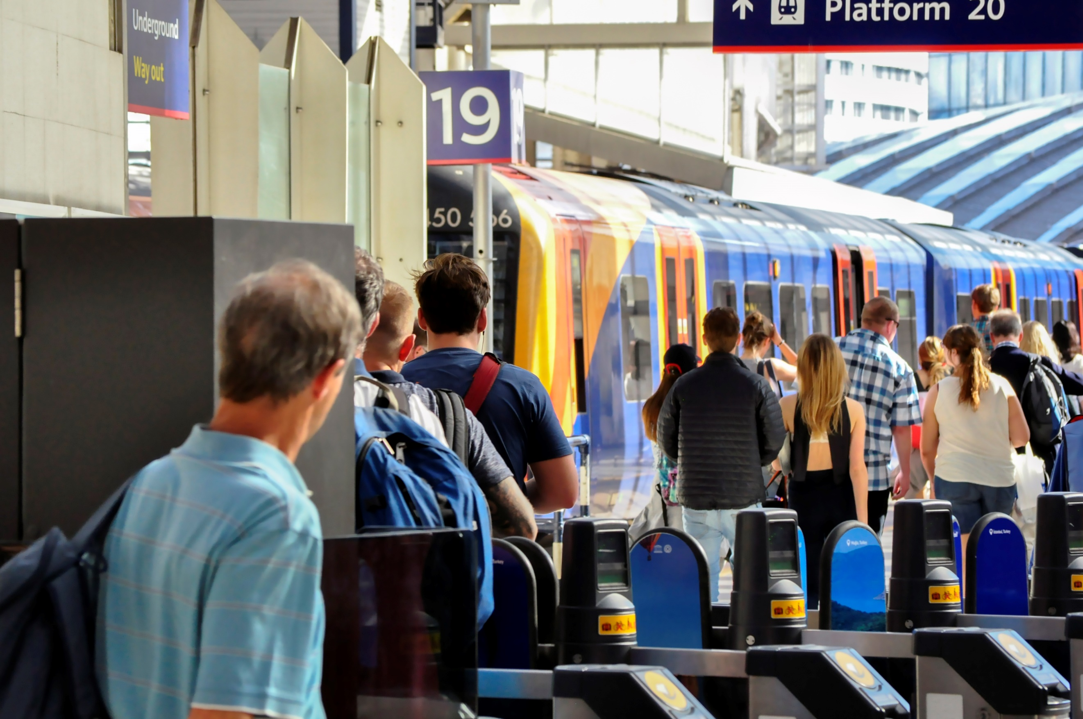

In the past decade rail travel has become ever more popular. Stations like London Waterloo and London Victoria now handle more passengers than the UK’s busiest airports and the numbers continue to rise.

Network Rail owns, operates and develops Britain’s railway structure, including 20,000 miles of track, 30,000 bridges, tunnels and viaducts and thousands of signals and level crossings. We also manage 20 of the UK’s largest stations and it is here that we need your help.

The rate of increase in rail passengers coming through our stations means we have to manage more waste, keep more passengers safe, comfortable and happy and ensure everyone can access the railway network.

We need to make sure that passengers can use the rail network and the stations to do the things they want to do and to move in the ways which suit them. Some want to get to their destination quickly whilst others prefer to take their time, perhaps have lunch along the way or chat with friends. They may be carrying heavy luggage or have a child in a pushchair or even be taking their pet with them. Some may have mobility issues which make it more difficult for them to move around the station or get onto trains from the platform.
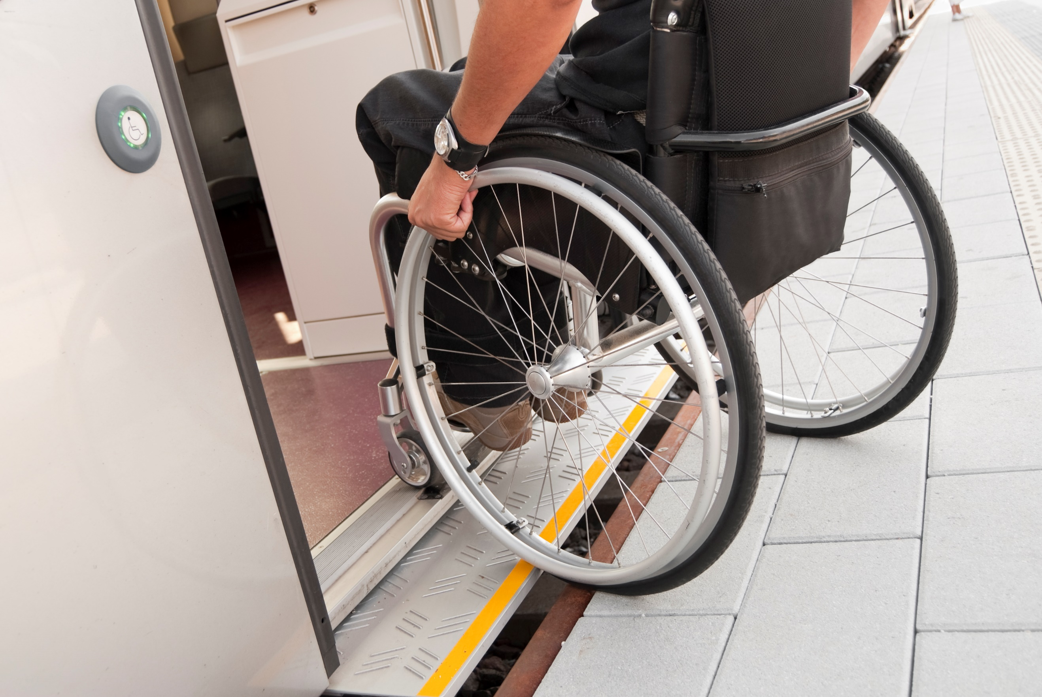

Here at Network Rail we want to make sure that our railway is fit for the future, no matter who you are and what you want it to do. We need your help.

Remember, engineering is about people. Today is your chance to make a difference, could you be our engineer...?
- 4 -

2. The Brief

The Network Rail team wants you to:

- Design and engineer ONE prototype which will help manage one aspect of increased passenger use on their stations. Your design MUST include at least one electronic circuit.

- Complete the planning and events log to show how you have designed your idea, and solved problems and worked as a team throughout the project.

- Present your prototype to the IET Network Rail judge(s).

You will need to demonstrate the skills and attitudes we are looking for so:

- be creative;
- plan carefully;
- work within the resources and the budget available;
- be realistic about what is achievable in the time available;
- be resilient and persevere with problems;
- record your thinking;
- keep to strict deadlines.

Considerations:

- Energy – how can we decrease the amount used and what sources do we have available to us?
- Sustainability – what materials can we use to ensure we are not contributing to global environmental issues?
- Capacity for growth – how can we make sure we can continue to increase the number of passengers?
- 5 -

Challenge schedule

50 mins | Register your team
 | Welcome and introduction
 | Project brief: Introduction to the Faraday Challenge
15 mins | Planning: Identifying the problems and generating initial ideas
5 mins | Team role selection: team decides on which roles they need
10 mins | Engineering apprenticeship: teams complete a short engineering task
1.5 hours | Development  - Shop opens  - Agree on final product designs  - Engineer design and modify where necessary  - Record progress in event log
10 mins | Teams are briefed on the content of the presentation and the engineering priorities.
30 mins | Development: Final preparations  - Finalise product  - Prepare presentation with notes  Shop closes at the end of this section
15 mins | - Submit accounting sheet to the shop keeper  - Practise presentation
55 mins | Presentation  - Teams present their designs to the judge(s)
15 mins | Award ceremony  - Final feedback and evaluation of the day  - Engineering teams depart

- 6 -
4. Engineering apprenticeship

In this circuit you are going to make a light dimmer or brighter depending on the level of resistance in a circuit.

Connect the circuit as shown below.

Crocodile lead
Crocodile lead
Battery pack

Crocodile lead

Light Dependent Resistor (LDR)
Piezo buzzer

Top tips:

- The LDR must be connected to the positive terminal of the battery (red wire).
- The red wire of the piezo buzzer must be connected next in the circuit on the positive terminal side of the battery pack.

Your LED may light up if you are working in a light room but, if not, try shining a torch on to the LDR. Ask your challenge leader if you do not have one.

Hold your hand over the Light Dependent Resistor (LDR) and listen to what happens to the buzzer.

Questions:

- What happens when you vary the light level on the Light Dependent Resistor?

- How could you vary or manage the resistance in your circuit(s)?

5. Shop resource sheet
- 7 -

Items to buy

Electrical components
Item | Description |  | Unit | Cost
Crocodile leads | 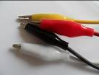 | Lead with crocodile clips at each end | Each | 4 Faradays
Piezo buzzer | 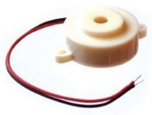 | Connect in a circuit to give a sound output | Each | 6 Faradays
LED – various colours | 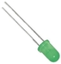 | Light Emitting Diode which lights up when connected in a circuit. Choose from red, orange, green or blue. | Each | 6 Faradays
Motor | 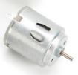 | Connect in a circuit to create clockwise or anti-clockwise movement. Will not work with a solar panel or an LDR. | Each | 6 Faradays
Solar motor | 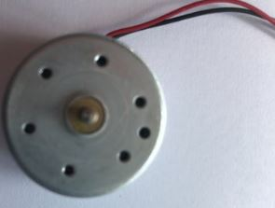 | Connect to a solar panel to create clockwise or anti-clockwise movement. | Each | 6 Faradays
Servo motor  (0 to 90 degrees) | 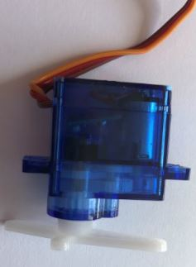 | Use with a servo motor control unit to control movement from 0º to 90º | Each | 6 Faradays
Servo motor (continuous) |  | Use with a servo motor control unit to control continuous movement through 360º | Each | 6 Faradays
Light Dependent Resistor (LDR) | 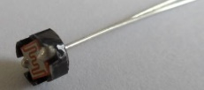 | Component that detects the light level and changes resistance in a circuit. | Each | 8 Faradays
Push to make switch | 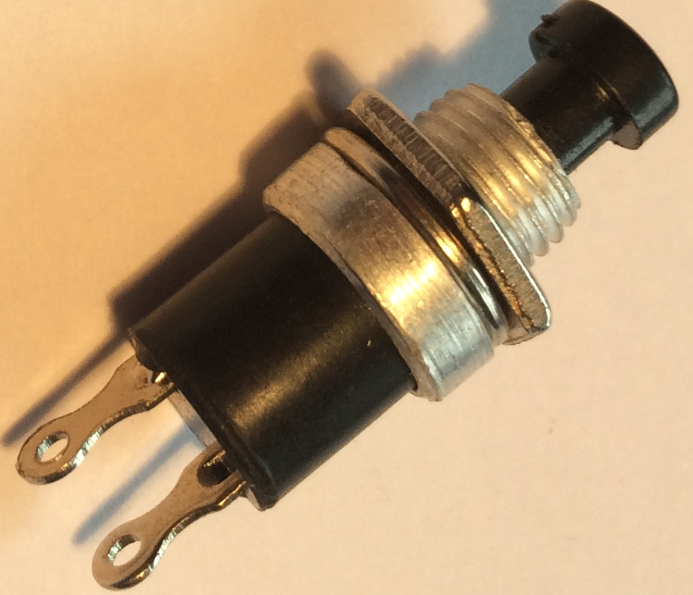 | Connects a circuit when pushed down and breaks the circuit when released. | Each | 6 Faradays
- 8 -

Servo motor control unit | 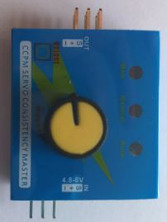 | Use this to control a servo motor. You MUST read the ‘How to …’ sheet before connecting this component. | Each | 8 Faradays
Motor holder | 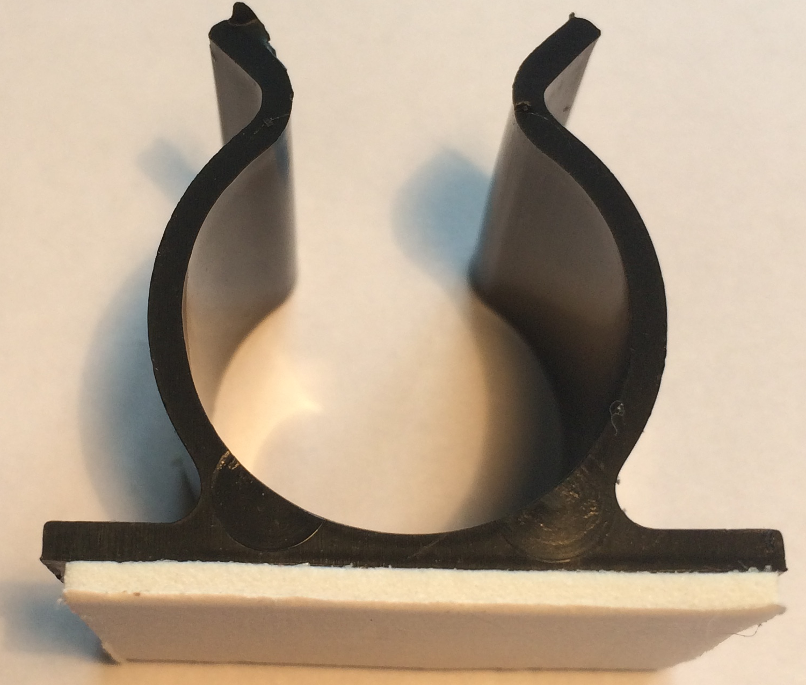 | Used to fix a motor or a syringe in position. NOTE: you will need the insert to connect a syringe. | Each | 4 Faradays
Gear attachment for motor |  | Used to connect a motor to a cog. | Each | 2 Faradays
Pulley attachment for motor | 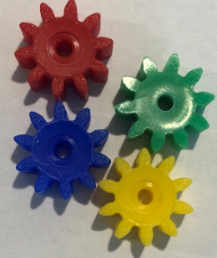  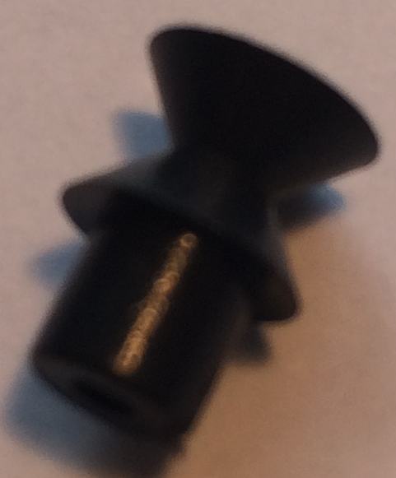 | Used to connect a motor to a pulley wheel – will need connector (e.g. elastic band) | Each | 2 Faradays
Solar panel | 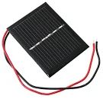  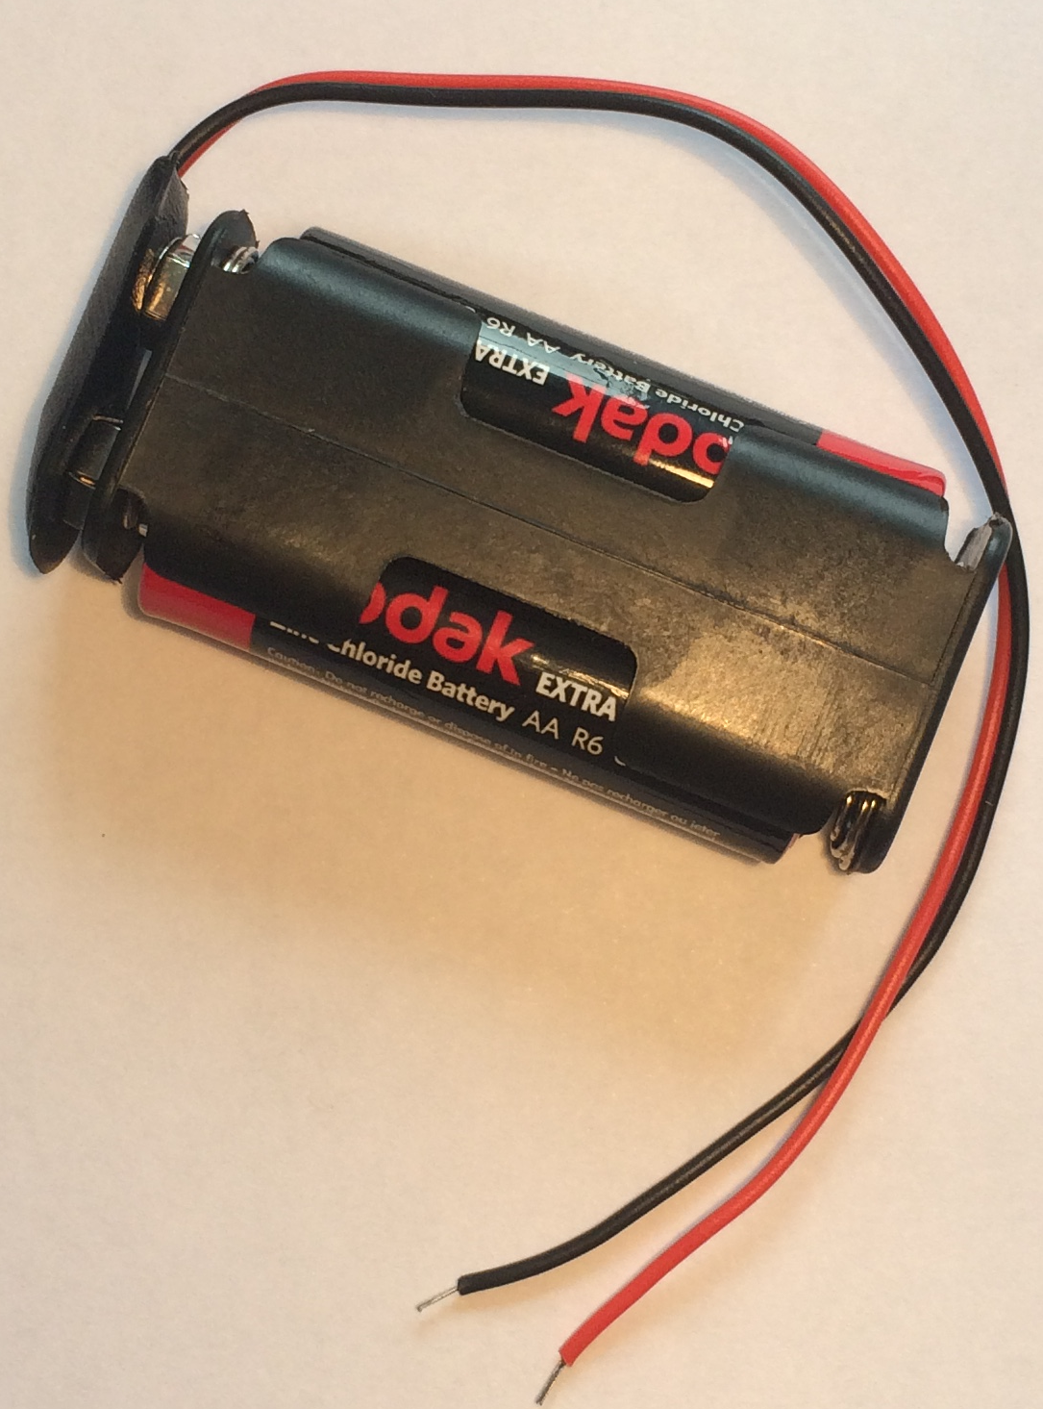 | Used to power components using the power of the sun. You MUST read the ‘How to …’ sheet before using. | Each | 6 Faradays
2AA cells in battery holder with battery snap |  | Used to provide power for your circuit | Each | 4 Faradays
4 AA cells in battery holder with jumper leads | 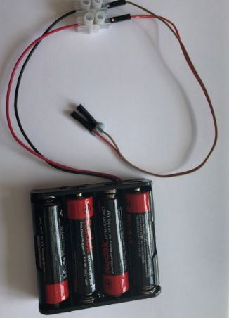 | ONLY to be used with servo motor control unit. | Each | 6 Faradays

Construction materials
Item | Description | Unit |  | Cost
Correx | Used to create structures | Piece |  | 6 Faradays
Plastic syringes with tube | Used to develop pneumatic system | Pair of syringes with plastic tube | 6 Faradays
Small cog | Used in gear systems with motors | Each | 2 Faradays
Medium cog | Used in gear systems with motors | Each | 2 Faradays

- 9 -

Large cog | Used in gear systems with motors | Each | 4 Faradays
Nail | Used for making moisture sensor | Pair | 2 Faradays
Dowel | Piece of solid cylindrical wooden rod used to create structures | Each | 4 Faradays
Pulley wheel | Used to connect to pulley attachments on motor | Each | 6 Faradays
Wooden wheel | Used with motors to drive something | Each | 4 Faradays
Plastic reel | Used in construction | Each | 4 Faradays
Coloured card | A4 sheet of card – assorted colours | Each | 4 Faradays
Aluminium foil | A conductive material which can be used to make pressure pads or switches (MUST NOT be used in place of connecting wires) | 10cm strip | 6 Faradays
Masking tape | Can be used to secure light parts in your design. NOTE: excessive use of tape will result in an additional charge | Roll | 6 Faradays
Sponge | Can be used to make pressure switches or enhance your design. | Each | 6 Faradays
Paperclip | Used to create switches or in construction | Each | 1 Faraday
Paper fastener | Used to create switches or in construction | Each | 1 Faraday
Elastic bands | Used to hold or create working parts, including driving pulley wheels | Each | 1 Faraday
Cable ties | Can be used to hold your structures in place | Each | 2 Faradays
String | Can be used as part of your product design | 30cm piece | 4 Faradays
Baking parchment | Can be used as part of your product design | 10cm strip | 6 Faradays
Wooden lolly sticks | Can be used as part of your product design | Each | 4 Faradays
Hire Centre Trade Card | Use this to hire various items from the hire section of the shop – see next page for details | One per team | 6 Faradays

- 10 -

Available with your Hire Centre Trade Card

These items can be hired from the shop if you buy a Hire Centre Trade Card. You will need to take it to the shop and show the shopkeeper each time you want to use of one of these items. You may only get one item at a time.

Stapler | Used to staple soft materials only
Hole punch | Used to make small holes in soft materials
Ruler | Used to measure any part of your product or additional items
Scissors | Used for soft materials only

Free to use

The cutting station may be used at any point BUT only 3 people will be allowed at this station at any one time. Please take care when using this equipment.
- 11 -

6. Assessment information and criteria

Criteria | Marks
- Planning | 13 marks
- Development of product | 20 marks
- Use of budget | 8 marks
- Product engineering | 30 marks
- The presentation | 15 marks
- Teamwork | 14 marks
Total | 100 marks
- Planning (13 marks)
Using the planning section of the Planning and Event Log, marks will be awarded as follows:
- Did they explain how their idea might help Network Rail manage the increasing numbers of passengers on their stations? (3 marks)
- Does the planning diagram detail how the prototype will be constructed? (5 marks)
- Have the electronics for the prototype been detailed? (5 marks)

- Development of product (20 marks)

Using the Engineering Event Log and observations of the team, marks will be awarded as follows:

- Event log 1 - Have they provided an accurate and informative record of development beyond a simple description including any problems and solutions? (5 marks)
- Event log 2 - Have they provided an accurate and informative record of development beyond a simple description including any problems and solutions? (5 marks)
- Event log 3 - Have they provided an accurate and informative record of development beyond a simple description including any problems and solutions? (5 marks)
- Are the priorities identified for the last 30 minutes realistic and appropriate?
(5 marks)

- Use of budget (8 marks)
Using the accountancy sheet and the prototype, marks will be awarded as follows:
- Was there an accurate record of spending? (3 marks)
- Was the budget used effectively? (5 marks)

- 12 -

4. Product engineering (30 marks)
Using the presentation of your prototype and what we have seen during the development period, marks will be awarded for:

- Did their prototype provide a realistic solution to the brief from Network Rail? (4 marks)
- Was the choice of electronic components appropriate for their intended design?
(4 marks)
- Was the choice of materials appropriate for the structure and/or mechanics of their intended design? (4 marks)
- Was the final prototype engineered well with all elements coming together in a well-structured and fit for intended purpose product? (6 marks)
- Did the judge(s) see the electronics and structure work together effectively as intended? (6 marks)
- Did the team push themselves beyond the minimum brief and incorporate at least two processes? (6 marks)

5. The presentation (15 marks)
Using the presentation of your prototype, marks will be awarded as follows:

- Did the team explain how their prototype works, including details of how and why they used the electronics and the mechanics in their design? (6 marks)
- Did the team identify the most challenging engineering aspect they faced during their development and how they overcame this challenge? (3 marks)
- Did the team explain what they did well in their teamwork and what aspects they could have improved? (4 marks)
- Did the team effectively demonstrate their prototype? (2 marks)

- Teamwork (14 marks)
Using the judges’ observations of your team throughout the day, marks will be awarded as follows:

- Did the team work well together with all members engaged in the project and any conflicts successfully resolved? (5 marks)
- Did the team work tidily and safely within the health and safety rules? (3 marks)
- Did the team persevere to resolve issues during the project and work largely independently? (6 marks)

- 13 -

